Maria

Pose 1 00:00:03:29

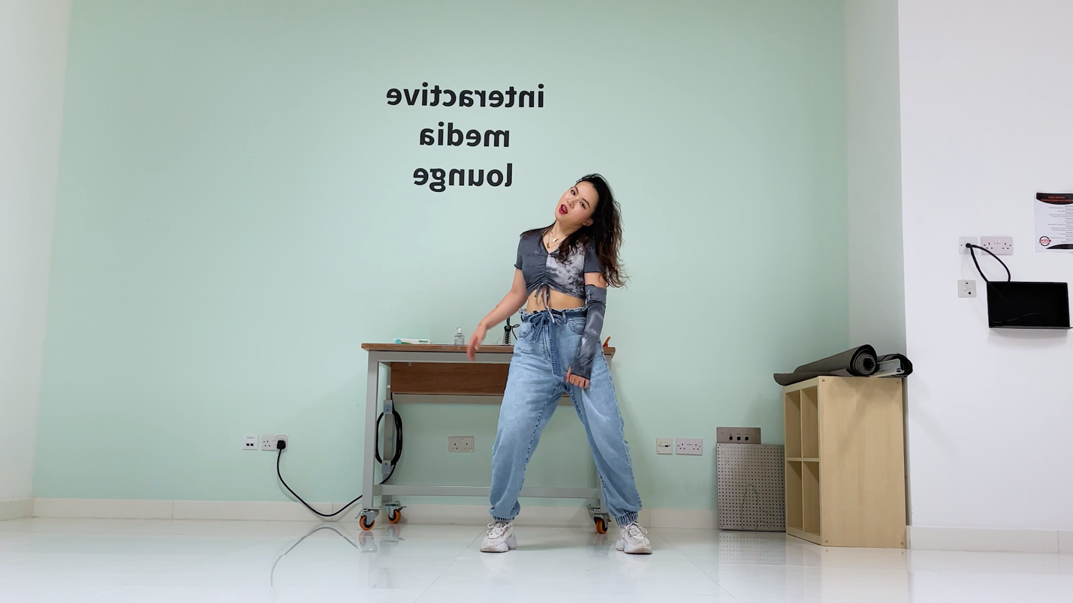

Pose 2 00:00:10:00

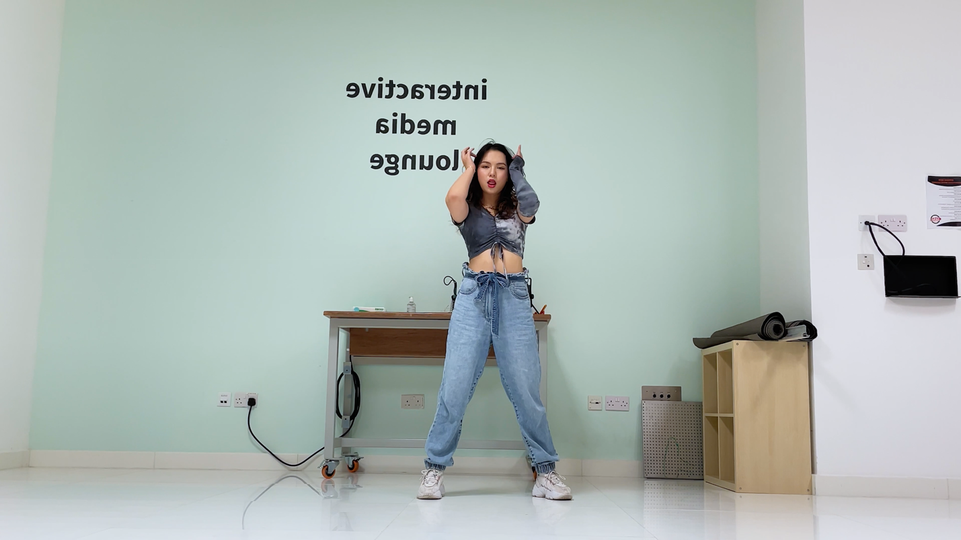

Pose 3 00:00:11:13

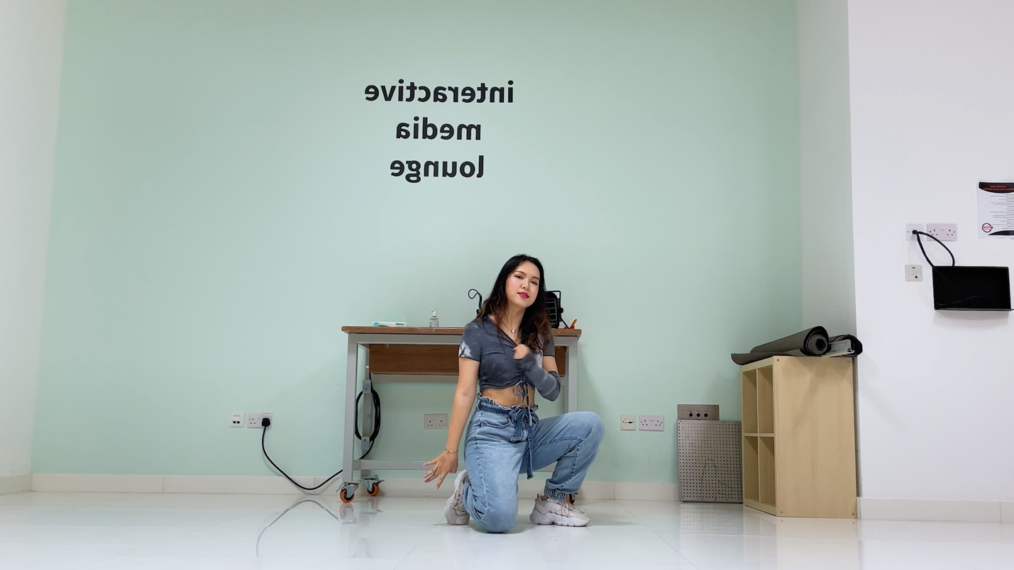

Pose 4 00:00:14:27

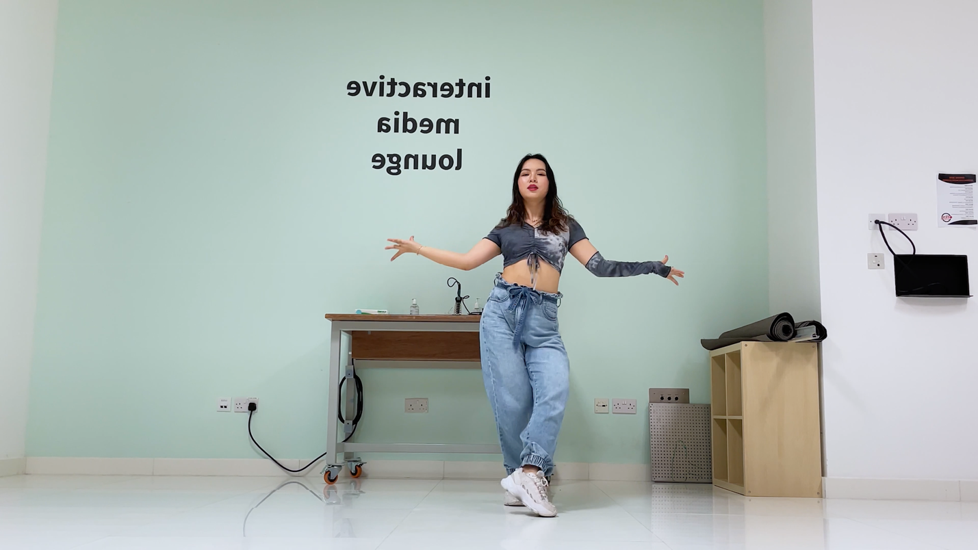

Pose 5 00:00:26:14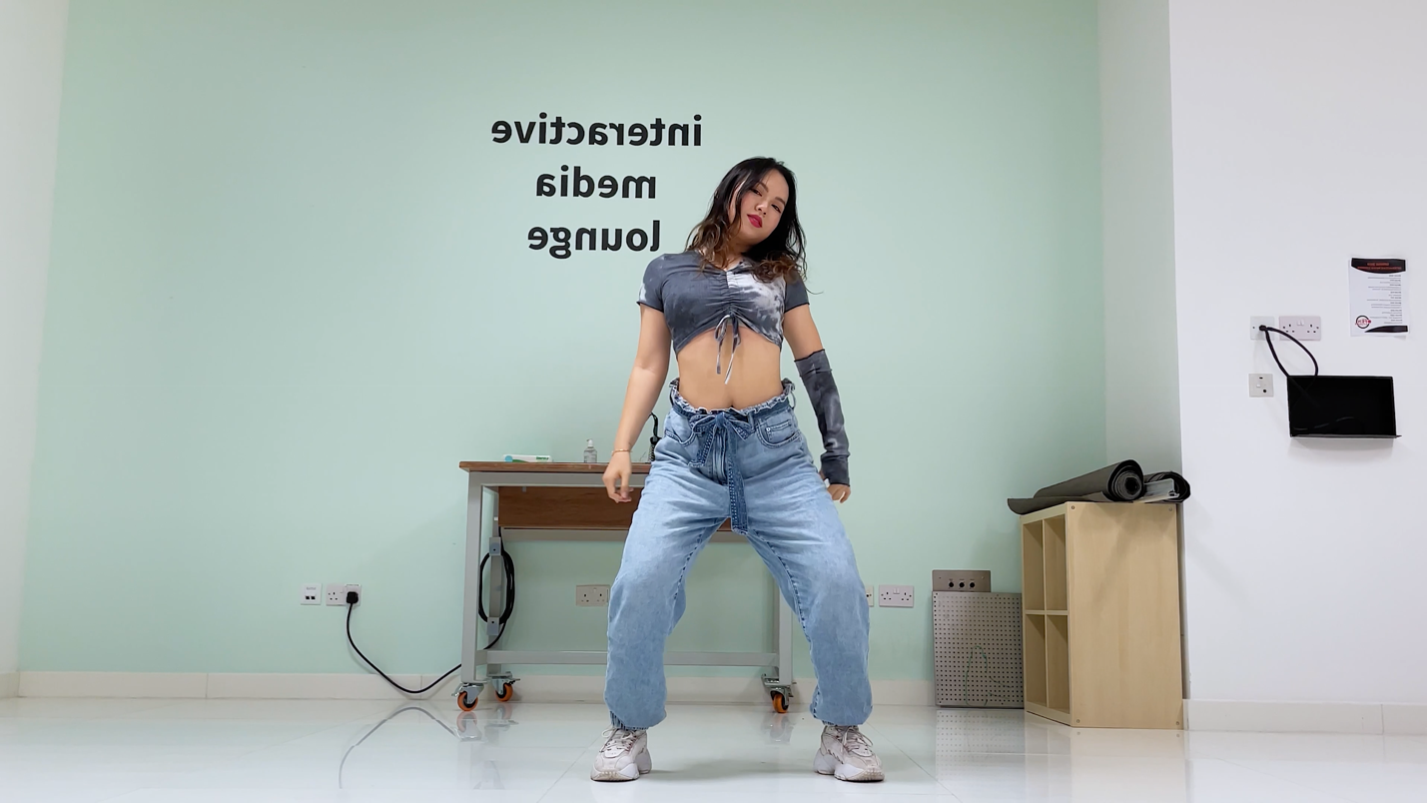

Pose 6 00:00:29:13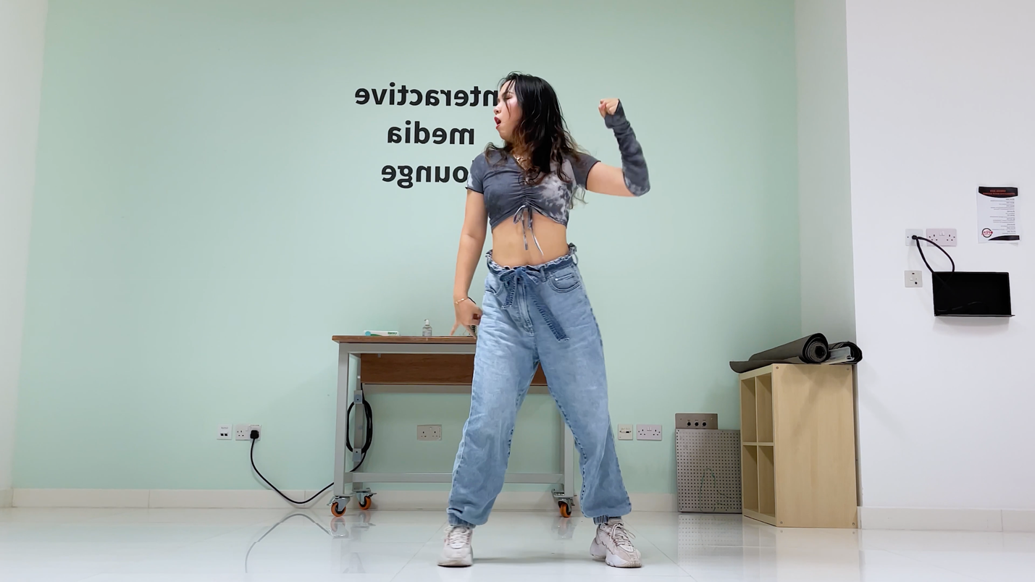

Pose 7 00:00:35:12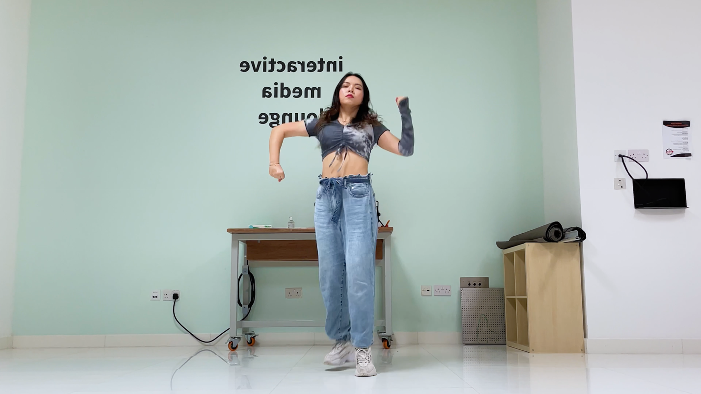

Pose 8 00:00:42:03

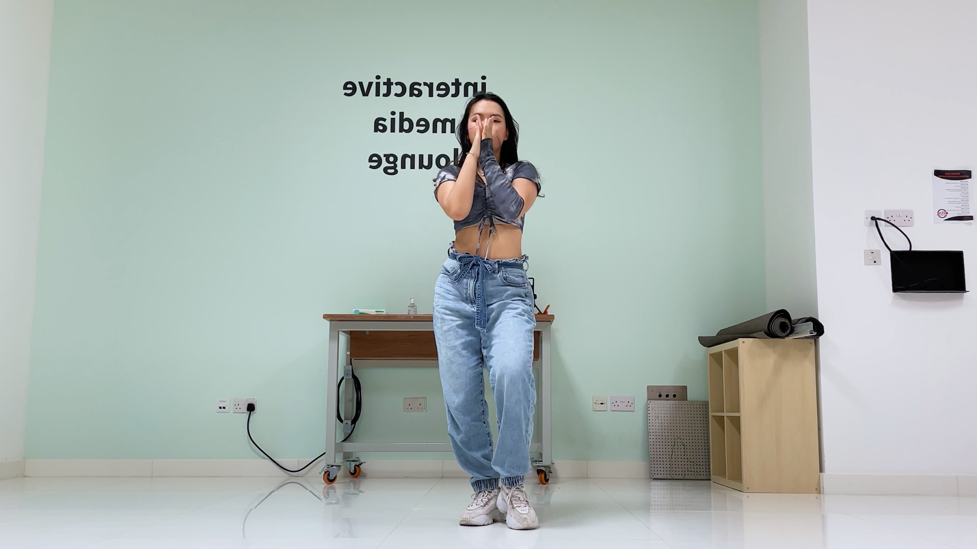

Pose 9 00:00:43:09

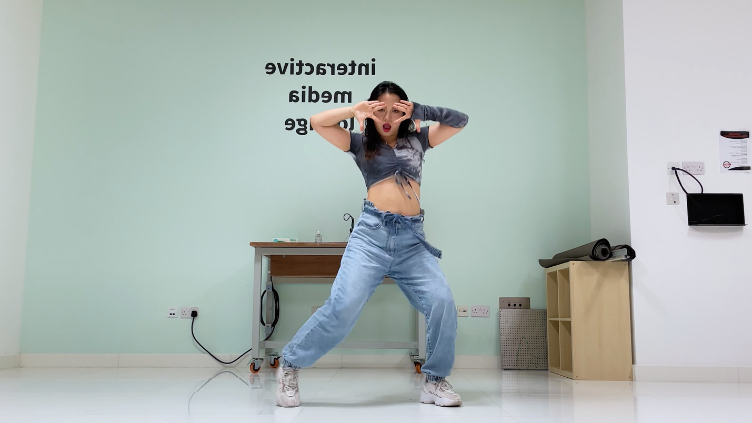

Pose 10 00:00:46:29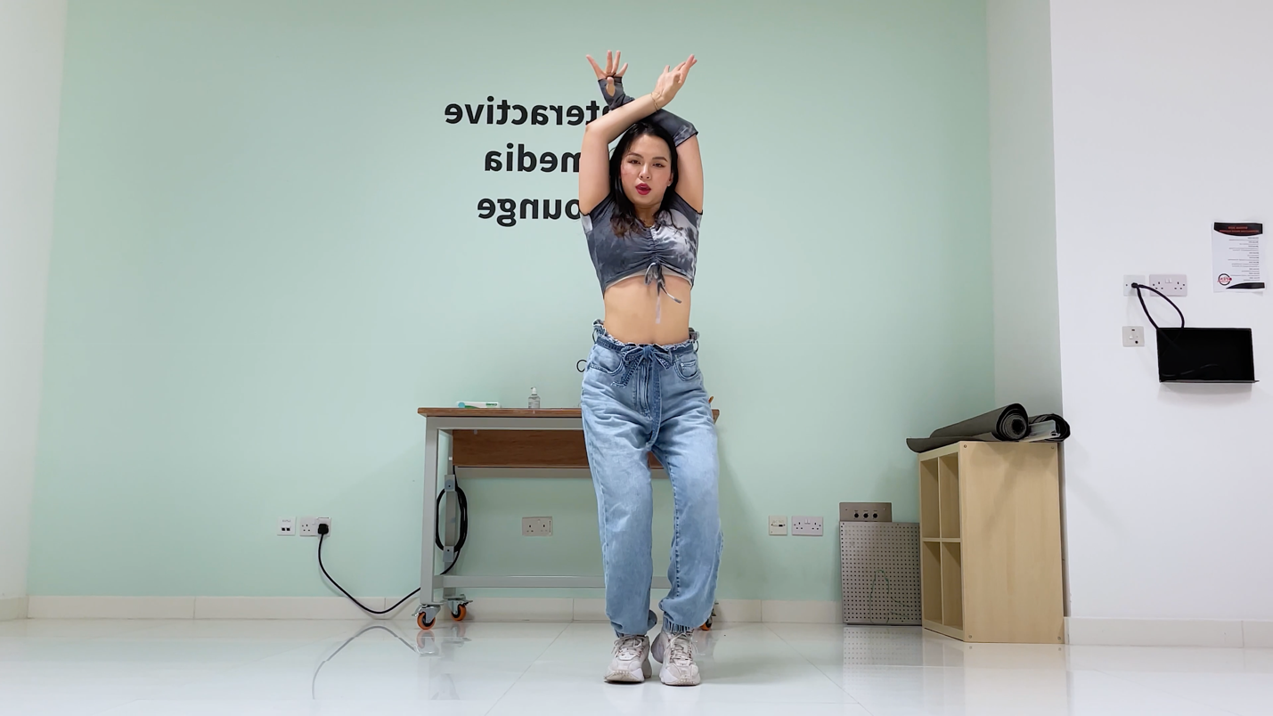

Pose 11 00:00:50:25

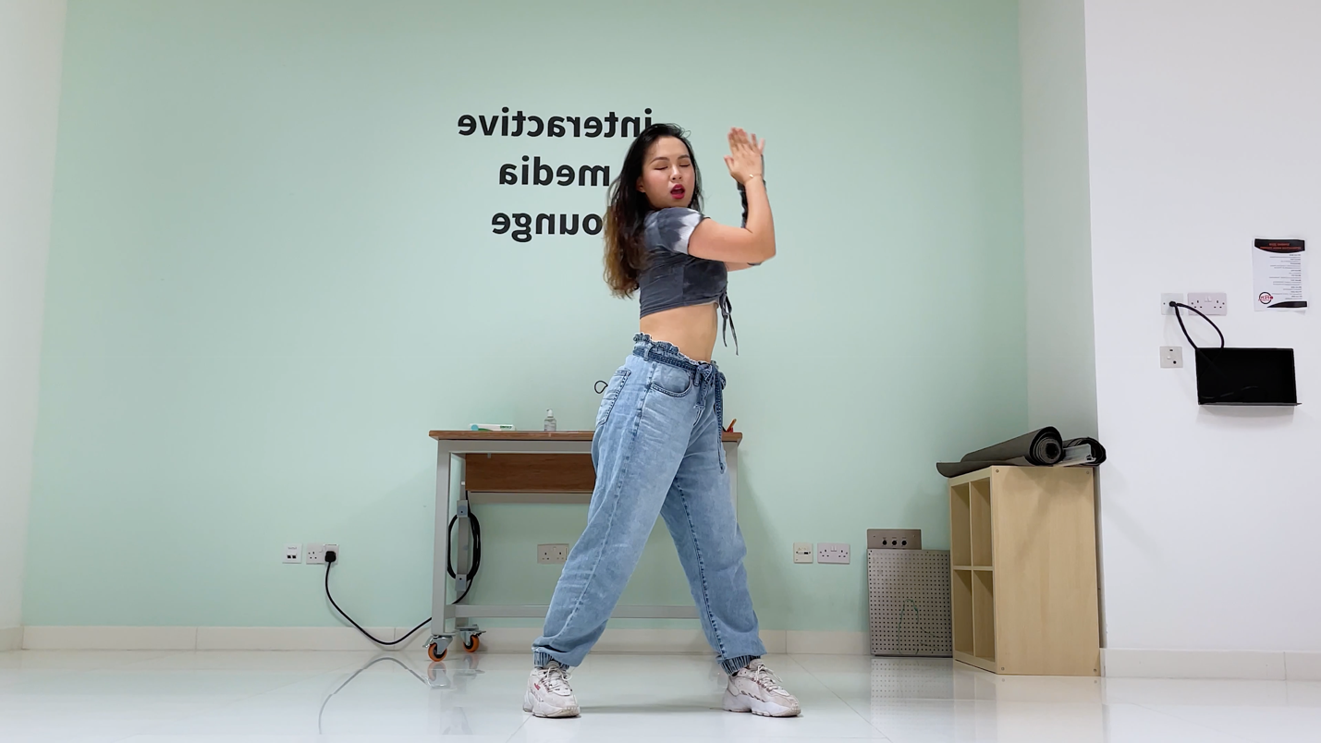

Pose 12 00:00:55:20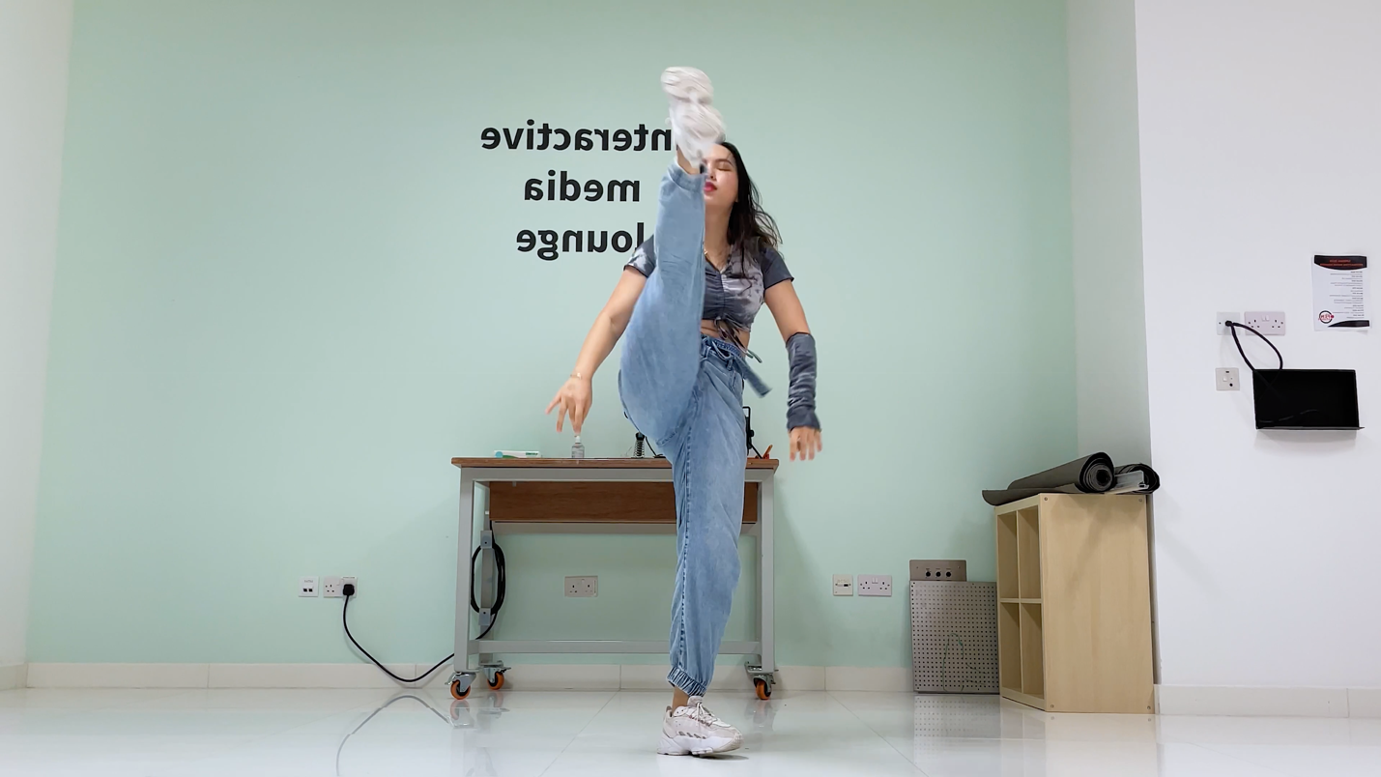

Pose 13 00:00:58:25

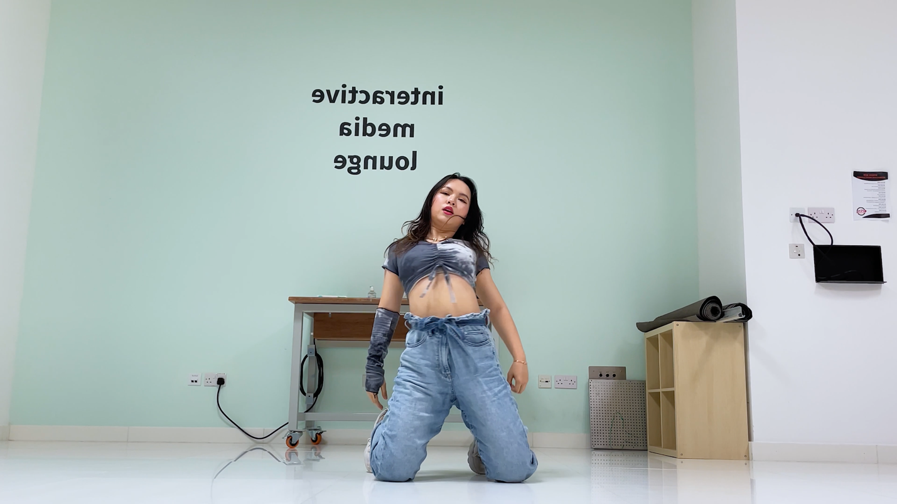

Pose 14 (OPTIONAL) 00:01:03:19

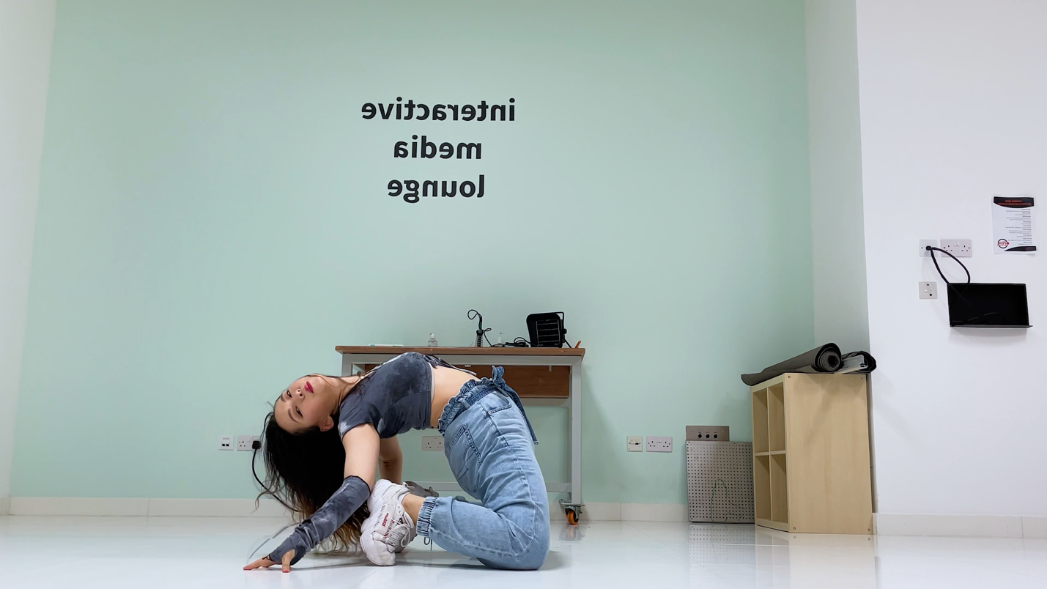

Pose 15 （DISABLED）00:01:12:04

